Toner Inventory System

User Guide

(Team Name)

Dustin, Shane, Tyler

COMPLETED:

* Intro
* Quick start guide
* Requirements(In Main Scenarios: Guide for search for a printer and search for a toner)
* (In Main Scenarios: Guide for printer or toner lists)
* Misc. troubleshooting

TO DO:

* (In Main Scenarios: Screenshot for printer or toner lists)
* (In Main Scenarios: Guide for sort printer and sort toner lists)
* (In Main Scenarios: Guide for Converting)
* (In Main Scenarios: Guide for Update printer and Toner csv)

-Show when curstock is less than minstock

Contents

1. Introduction
2. Quick Start Guide
3. System Requirements
4. Main Scenarios of Use
5. Troubleshooting

1.Introduction

The DTCC Toner Inventory System is an application with a simple user interface to access information on site at Del Tech colleges managing printer, toners, and current stock. This document will provide instructions for using the application to view printer/toner lists, As well as viewing and searching for individual printers or toners that need to be serviced.

2. Quick Start Guide

1. Have Dtcc Toner Inventory unzipped and in source folder of java IDE.
2. Launch Eclipse or IntelliJ from desktop.
3. Run DTCC Toner Inventory as Java Application

3. System Requirements

The DTCC Toner Inventory System should be installed on a PC or VM running the latest version of Windows 10(64-bit). Refer to the [System Documentation](https://drive.google.com/open?id=1uuW8DsdZqberjpSr5YRrOx5vP1OLpQFw8KCO5expxYM)

for further details on the instructions and installation process.

4. Main Scenarios of Use

**4.1. CSV Selection Menu**

1. When program is launched as a java application the UI should appear. Default printer and toner csv’s are chosen or the user can choose a specific file.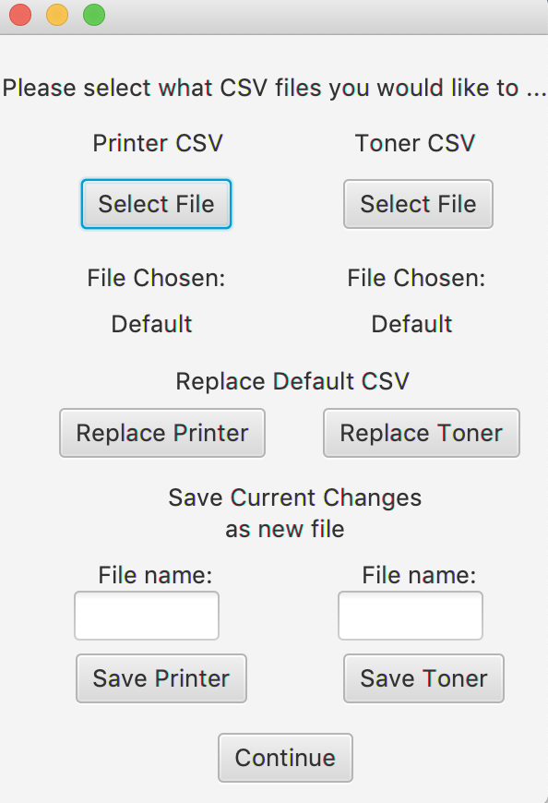

**4.2. Searching for a printer**

1. After the menu system has appeared, to search for a printer the user should Input their choice of how they would like to search for your printer.

**\*Please use dtcc barcode, description(model), category(ex. Color Laser Printer), location (building/room#), serialNumber, manufacturer, division(ex. Instructor), department (ex. Nursing), campus (ex. Stanton), or status (ex.Active)**

3. Printers with the filtered attributes will be displayed.

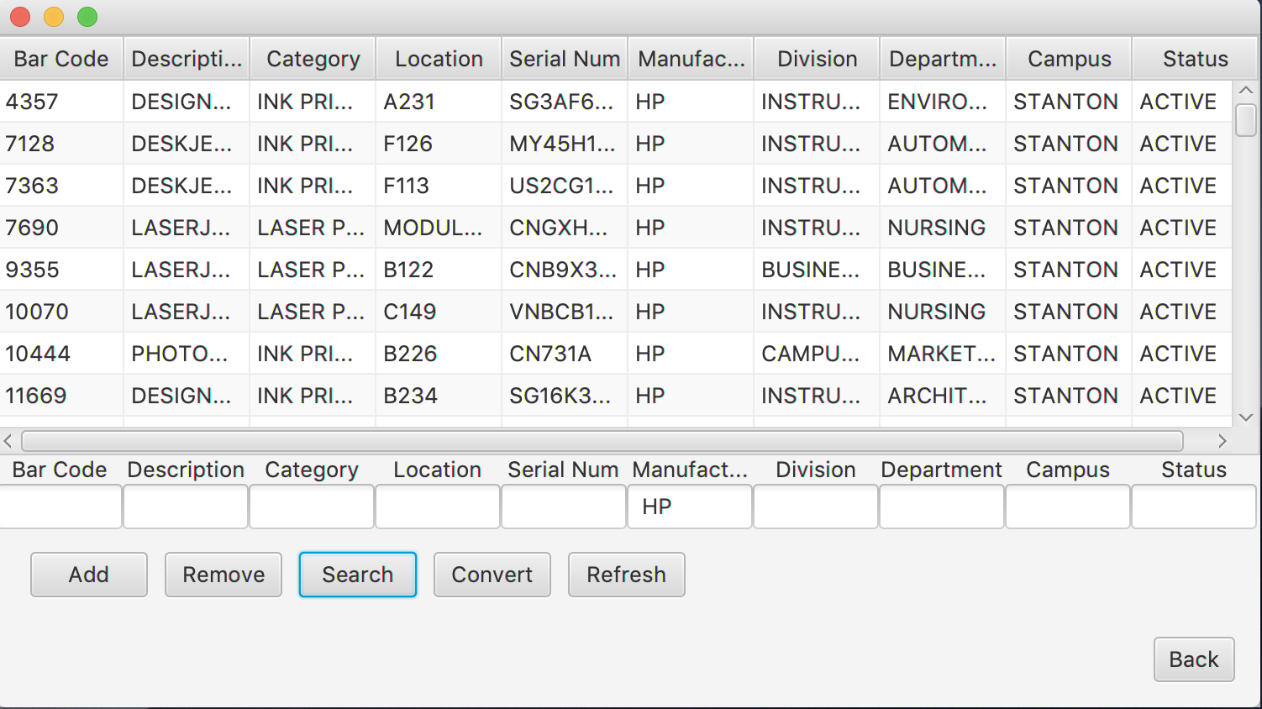

**4.3. Searching for a toner model**

1. After selecting Toner from the main menu the toner list will be displayed along with different options for how the user would like to search by.
2. After the menu system has appeared, to search for a toner model the user should Input their choice of how they would like to search for their toner cartridge.

**\* Please search using printerModel, brand, tonerModel, printers, minimumStock, currentStock, what must be ordered, or by what is needed.**

1. Toner or toners with the filtered attributes will be displayed.

(Example filters toners by those needed to Order)

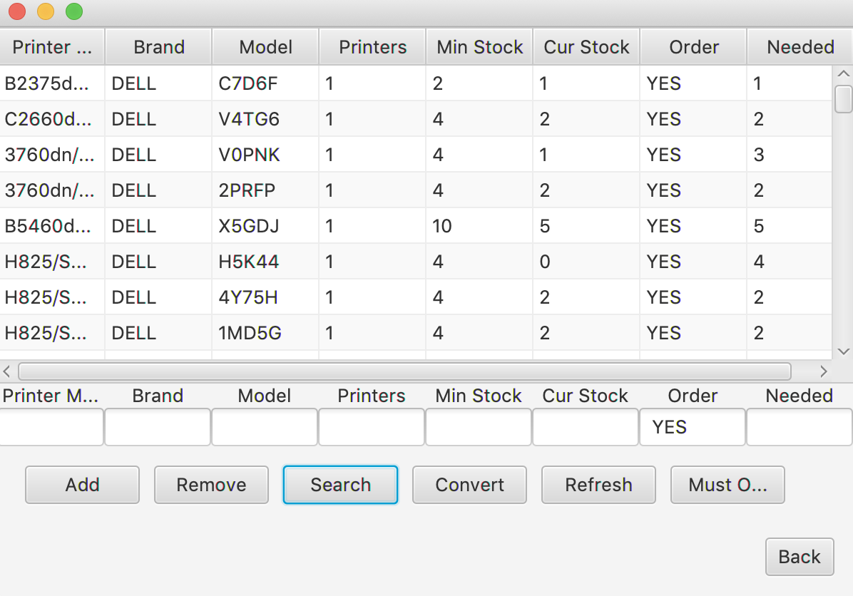

5. Troubleshooting

**5.1 Error: File content mismatch.**

A message will be displayed in the event that an invalid file is chosen for the program. Try again with a valid csv file to display the main system menu. This must be done for both the printer and toner csv files.

**5.2 Starting a new search or refresh display**

At any point after any search, sort, conversion, or list display if lost you can return to the main menu by inputting “0” into the console.